Name: Date:

TOPIC: SCALE FACTORS

A dilation is a transformation in which a figure is enlarged or reduced with respect to a fixed point C called the center of dilation and a scale factor, k, which is the ratio of the lengths of the corresponding sides of the image and the preimage.
- When the scale factor k > 1, a dilation is an enlargement.
- When 0 < k < 1, a dilation is a reduction.

Example:
Find the scale factor of the dilation. Then tell whether the dilation is a reduction or an enlargement.
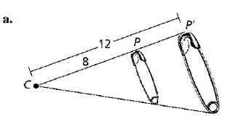
Solution:
Because $\frac{CP' }{CP}=\frac{12 }{8}$, the scale factor k = $\frac{3 }{2}$. So, the dilation is an enlargement.

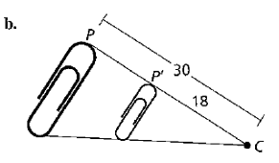
Solution:
Because $\frac{CP' }{CP}=\frac{18 }{30}$, the scale factor k = $\frac{3 }{5}$. So, the dilation is a reduction.

Real Life Example:
You are making your own photo stickers. Your photo is 4 inches by 4 inches. The image on the stickers is 1.1 inches by 1.1 inches. What is the scale factor of this dilation?

Solution: The scale factor is the ratio of a side length of the sticker image to a side length of the original photo, or $\frac{1.1 in }{4 in}$
For questions #1-4, find the scale factor of the dilation. Then tell whether the dilation is a reduction or an enlargement.
1. 2.
. 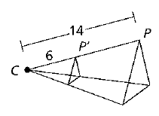 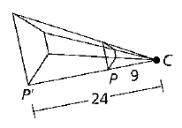

3. 4.
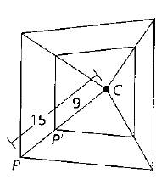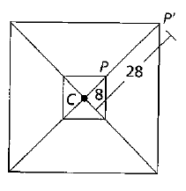

5. You receive wallet-sized photos of your school picture. The photo is 2.5 inches by 3.5 inches. You decide to dilate the photo to 5 inches by 7 inches at the store. What is the scale factor of this dilation? (Remember to ask yourself: “is this an enlargement or a reduction?”)

6. Your visulally impaired friend asked you to enlarge your notes from class so he can study. You took notes on 8.5-inch by 11-inch paper. The enlarged copy has a smaller side with a length of 10 inches. What is the scale factor of this dilation?

7. For each problem you are told if an enlargement or a reduction took place. Using that
information, find the scale factor of the dilation. Then find the value of the variable.

- Enlargement
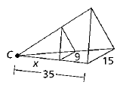

- Enlargement
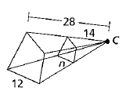

- Reduction
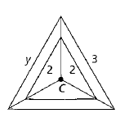

- Reduction
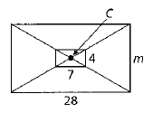

8. Describe and correct the error in finding the scale factor
a)
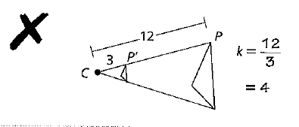

b)
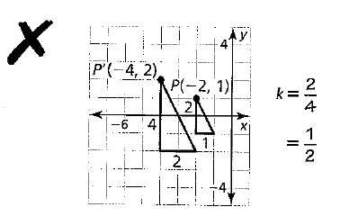
9.
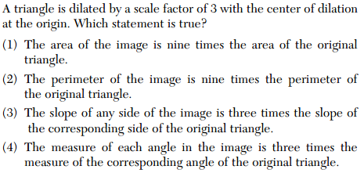
10.
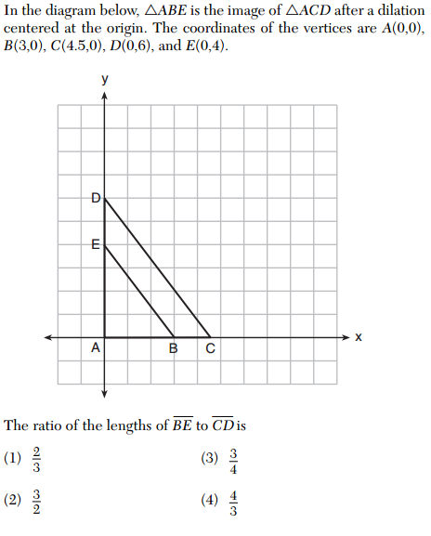

11.
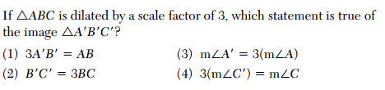
12.
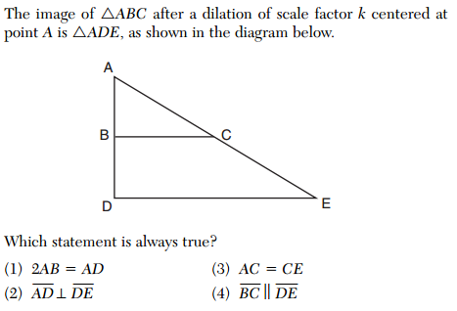
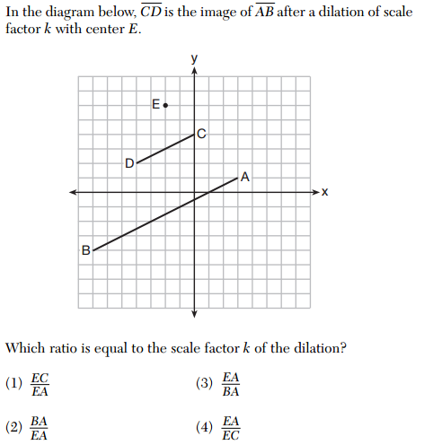
13.

